Writing Feedback Form
Name: _______________________________________
Profession: _____Medicine__________________________
Task: _______________________________________
Date: _______________________________________
Overall
The letter is mostly well written, and the recipient would understand what is required of them. However, the recipient also needed to know that the wrist splint should be custom made and that it should be in the neutral position. You mentioned the ergonomics assessment, but the grammar was inaccurate which made it sound confusing. The final paragraph felt rushed, which was unfortunate as it had key information from the discharge plan.

While the language and style is mostly good, there were problems with the second paragraph. Partly the language was confusing, (see language) but also the inclusion of irrelevant information was slightly distracting. There was no need to mention information about the EMG, as this would not concern an occupational therapist.

There were also opportunities to be more direct. The style of these letters is concise and direct, and some of your sentences could be expressed in a more direct way (see genre and style).

Purpose
The purpose is clearly stated.

When using an appositive, sometimes it’s nice to add more information.
You wrote:
“I am writing to refer MS Weston, a 55 year old, who is...”
You can add more information to the appositive as the recipient already knows the patient’s age:
“I am writing to refer MS Weston, a 55 year old supermarket manager, who is...”
Content
The content is mostly appropriate. However, key information was omitted about the wrist splint being in a neutral position. The language was not clear when writing about an ergonomics assessment.

An ergonomics assessment is related to the workplace, so it would have been useful to mention the patient’s occupation (supermarket manager).
Irrelevance was mostly avoided however.

Conciseness and clarity
The letter is a good length. However, there are opportunities for you to be more concise.

You wrote:
“I would be grateful if you could apply a wrist splint, and it should be in appropriate position, and if you could assess it ergonomically.”
You have joined the clauses using “and” but this sounds unnatural. You could have used a relative pronoun (which/that) which would aid professionalism:
I would be grateful if you could apply a wrist splint which/that should be in an appropriate position, and if you could assess it ergonomically.
Also, the wrist splint cannot be assessed ergonomically, so this should have been in a separate sentence.

Genre and style
The style is mostly what is expected, however there are opportunities to be more direct:
You wrote:
“Today, Ms Weston was reviewed in the clinic…”
That is OK, but the recipient really just wants to know what happened at the review. Compare:
Upon review, today Ms Weston agreed to wear a wrist splint…

You wrote:
“It might also be worth mentioning...”
Better to state:
It is also worth noting…

Layout
The organisation is generally good, however, you could have grouped the information about the patient’s hand together in paragraph 2. For example, the sentence: “She has no history of trauma…” this would be better at the end of the paragraph.

Overall, paragraphing and layout is good.

Language
“Her sleep was disturbed by that, but it was alleviated by fingers movement.”
Using “by that” is a little unnatural. It might sound better to simply say:
Her sleep was, therefore, disturbed…
Or:
She consequently experienced sleep disturbance…
The second clause is also unnatural. It’s probably better not use the case notes as it is more natural way:
…by moving her fingers.
As the subject of the two clauses is the same, you can omit it from the second clause:
“Her sleep was disturbed by that, but (it) was alleviated by fingers movement.”
You can also join the two clauses by using a relative pronoun (which/that)
She experienced sleep disturbance which was alleviated by moving her fingers.
You wrote:
“She has difficulty in manipulating objects using her hand.”
I think a better word than manipulating is “Handling.” Also, it might be better just to omit “with her hand” as this is obvious. Remember the style of writing is concise and direct.
She has difficulty handling objects.

You wrote:
“Please note no history of trauma.”
The phrase “please note” has a comma after it, and you would need to then write a sentence with a subject and verb:
Please note, there is no history of trauma.

The final paragraph felt rushed:
You wrote:
“in the view of the above…”
You need a capital letter and with “the”:
In view of the above,

You wrote:
“…she is a case of type 2 diabetes, hypothyroidism and has morbid obesity.”
You can’t have obesity, but you are obese. It is probably more natural to say:
She has type 2 diabetes, hyperthyroidism and is morbidly obese.

Avoid contractions:
“Please don’t hesitate to contact me…”
Please do not…

Spelling:
Particularly
Conservatively
Neurological
Hyperthyroidism
Grateful

When you write a conditional sentence (with “if”) only use the comma if you start with the if clause:
Please do not hesitate to contact me if you have any queries. (no comma)
If you have any queries, please do not hesitate to contact me. (comma)

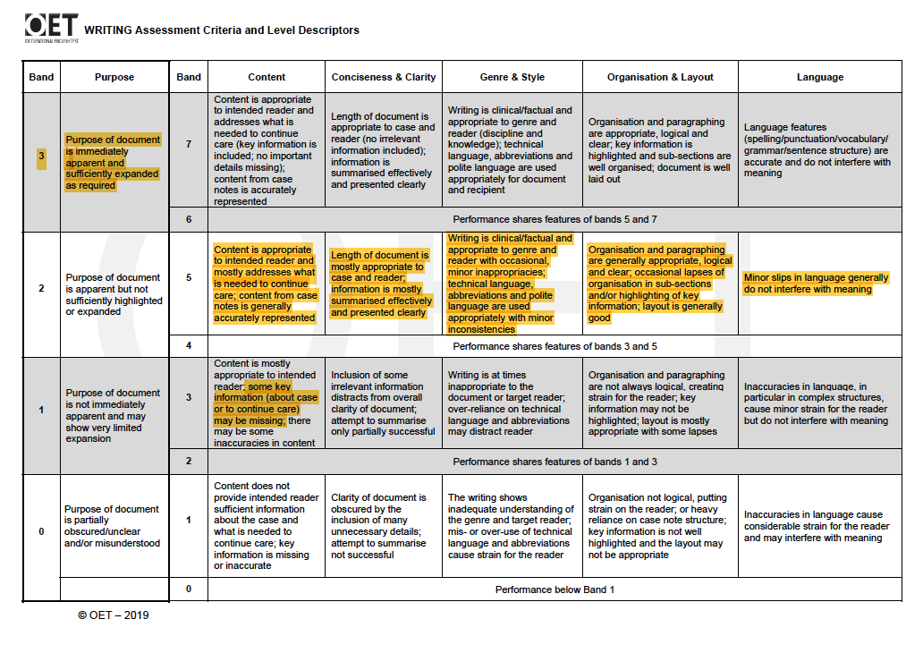

Sample letter

